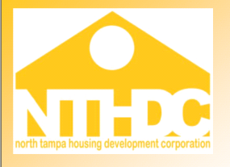

Date:

Property Name:

HAP Contract Number:

SUBJECT: Owner/Agent certification of decontrolled non Section 8 rent potential

HUD requires the comprehensive use of a project’s rent potential to be used to calculate the OCAF and Budget Based adjustment, even in cases where HUD no longer controls the rents. As such please list below all decontrolled non section 8 rent potential.

No. of units Unit Size Current Rent
$
$
$
$

Please read and sign the following statement to certify that all decontrolled non Section 8 rent potential has been disclosed.

I certify that all rent potential for _______________________ has been disclosed, and as such I understand that this information will be included as part of my annual rent adjustment.

Name (Sign & Print)

Title

Date

